**Final Project**

PART I:

1. The basic “idea” of this program is to function as a chat application. The app sends and receives messages between two users with the help of their Email Id.
2. Inputs:
3. Email Id
4. First & Last Name
5. Password

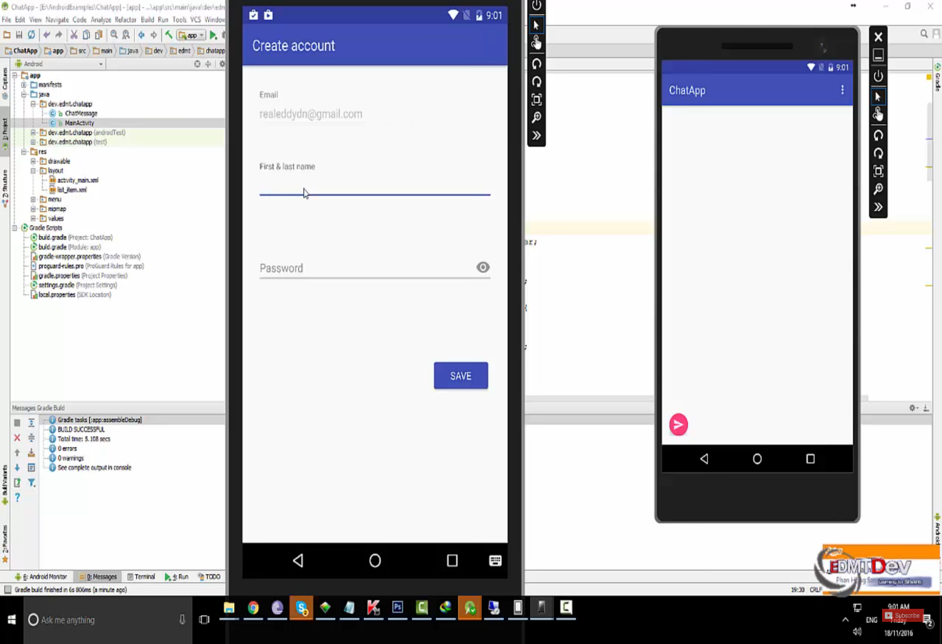

Outputs:

1. The login screen
2. The message box
3. Contact list
4. I have created a flowchart for the application. It is in the pdf form with the name “ChatApp Flowchart” on one of the files I have attached.

PART II:

I have used “Google Firebase” in my chat application which manages the users in a simple and secure way. Firebase Authentication offers multiple methods to authenticate, including email/password, third-party providers like Google or Facebook, or using your existing account system directly. I have just included email/password in the ChatApp due to time restrictions. I will discuss more in the part III on what I would have done if I had more time.

Firstly, I have done the <Relative Layout> for the App. I have a file called “App Designs” that has the process and pictures of my app layout. After I did the layout I created a new java class that contains **private** String **messageText**; **private** String **messageUser**; and **private** long **messageTime**. Then in the main activity I imported all the files from different widgets & views of android with google firebase attached to them. I have used inheritance when I extended the main activity from the **AppCompatActivity parent class.** Moreover, I created different methods for instance, **onOptionsItemSelected; onCreateOptionsMenu; onActivityResult; onCreate; displayChatMessage.**

However, there is one compilation error in the main activity. I did a lot of research on that error but nothing really showed up. I think it is an error specific to my computer. Although, the program does not work on my computer due to the compilation error, with more time in hand, I would definitely research more on the error ad make the program work.

PART III:

1. Considering that it was my first time building an app, the overall program turned out really well with one small compilation error. While programming the app, there was one error where symbol R could not be resolved. This error was quite huge since my overall coding was being affected by it whenever I used the symbol. Therefore, to resolve that symbol I had to change the version of the APK from 15 to 16 and also make changes to the firebase version from 1.0.0 to 0.6.2. With that being done, I had to implement **maven {url 'https://maven.fabric.io/public'}** into the program. Finally symbol R was resolved and the small errors due to that symbol were also fixed in the final product.
2. The key moments in the program development were quite broad. At first it was difficult to create and build an app since it was my first time doing it. Initially, I had started my program on visual studio due to its cross-platform feature in the app development. This means that if I am creating an android app, the code of the app will be linked to the IOS platform where I can make an IOS app as well. However, since it was a bit difficult for me to learn a new programming language (C#) on visual studio, I decided to do the whole program again in android studio which used Java as its programming language. Java was easier for me to implement since I did Java in class with Object Oriented Programming which really assisted me in the building the application.
3. The first thing I would do to my program is that I would fix the compilation error and make the program work. Secondly, I would do further research on my project and add features to the chat application such as group chatting, voice and video calling. Thirdly, I would add the google real-time database which stores and syncs data between users and devices in realtime using a cloud-hosted, noSQL database. The data remains available even if app goes offline, providing a great user experience regardless of network connectivity. Lastly, I would assist the app with cloud storage which stores and shares images, audio, video, or other user-generated content easily with powerful, simple, and cost-effective object storage.